**PREVIOUS LAB STATEMENT 2**

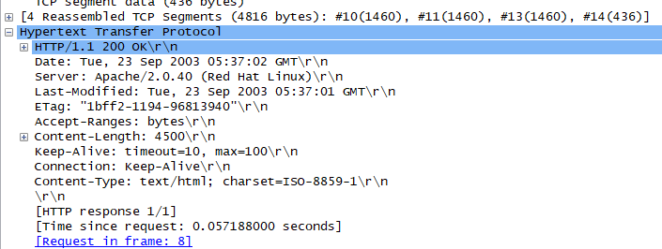

Content length is 4500 bytes.

The original length is 4500 that is size of content, the 490 bytes in response message are header bytes.

**Lab Statement 1**

1. Port 20 is data transfer channel used to transfer files for ftp and port 21 is for command channel.

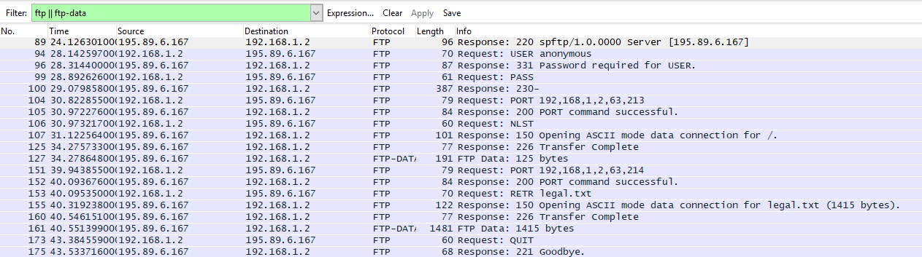

89: Establishes connection between source 195.89.6.167 and destination 192.168.1.2

Response code: 220, Response argument: spftp/1.0.000 Server [195.89.6.167]

94: Requests and checks username entered from source.

Request command: USER, Response argument: anonymous

96: Gives response to source to let it know that username is correct and prompts to enter password

Response code: Username okay, need password (331), Response argument: password required for USER

99: Request password from source

Request command: PASS

100: Let the user know that entered password is correct

Response code: user logged in, proceed (230)

Response argument:

104: Requesting connection through IP address and port number

Request Command: PORT

Request arg: 192,168,1,2,63,123

Active IP address: 192.168.1.2 (192.168.1.2)

Active port: 16341

105: Gives response to user to let them know that connection is established

Response code: 200

Response arg: PORT command successful.

106: Request NLST command from user

Request command: NLST

107: Gives response to user to let them know that ASCII mode for data connection has been opened.

Response code: File status okay; about to open data connection (150)

Response arg: Opening ASCII mode data connection for /.

125: Closes data connection and lets user know that transfer is complete

Response code: Closing data connection (226)

Response arg: Transfer Complete

127: Downloading the data on user host

151: Request connection once again after file transfer is complete

Request command: PORT

Request arg: 192,168,1,2,63,214

Active IP address: 192.168.1.2 (192.168.1.2)

Active port: 16342

152: Give response to let user know that connection has been established

Response code: Command okay (200)

Response arg: PORT command successful.

153: User requests legal.txt file to be downloaded

Request command: RETR

Request arg: legal.txt

155: Gives response to user to let them know that ASCII mode for data connection has been opened.

Response code: File status okay; about to open data connection (150)

Response arg: Opening ASCII mode data connection for legal.txt (1415 bytes).

160: Give response to user to let them know that file transfer has been completed

Response code: Closing data connection (226)

Response arg: Transfer Complete

161: Download the file on user host

173: User sends request command to end ftp session

Request command: QUIT

175: server closes ftp connection in response to user’s “QUIT” request

Response code: Service closing control connection (221)

Response arg: Goodbye.

**LAB Statement 2**

1. They are sent of TCP

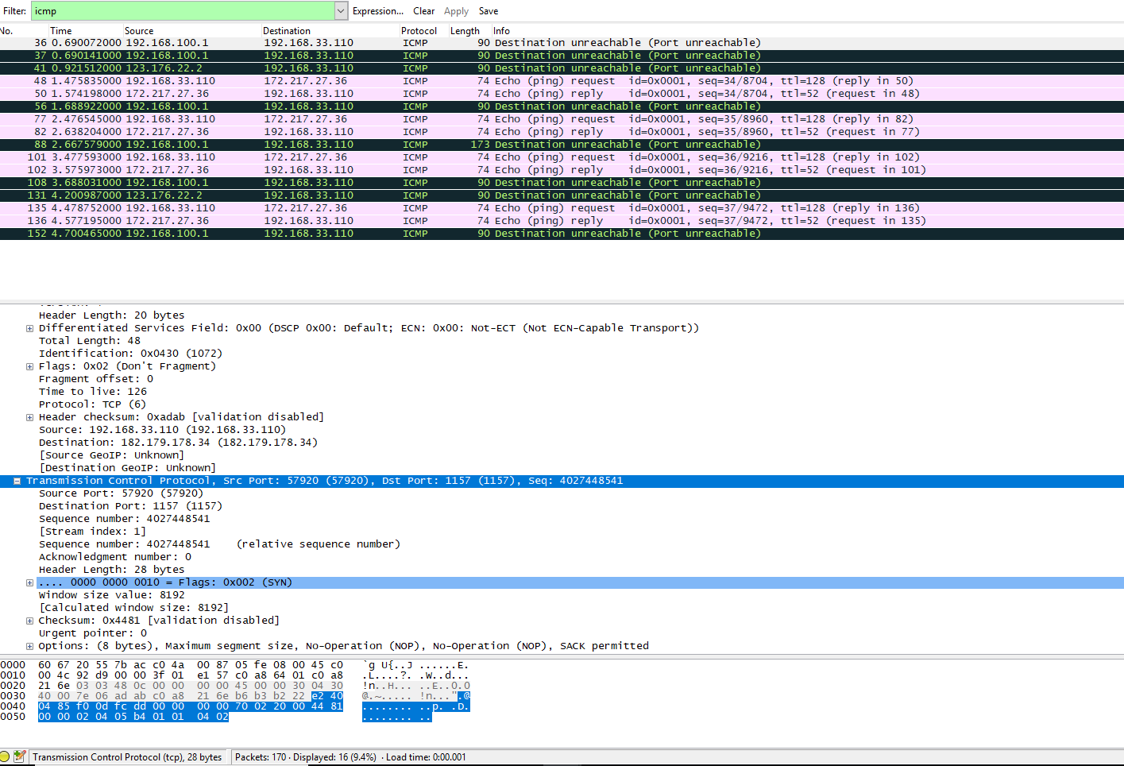

1. Link-layer address of host: 60:67:20:55:7b:ac

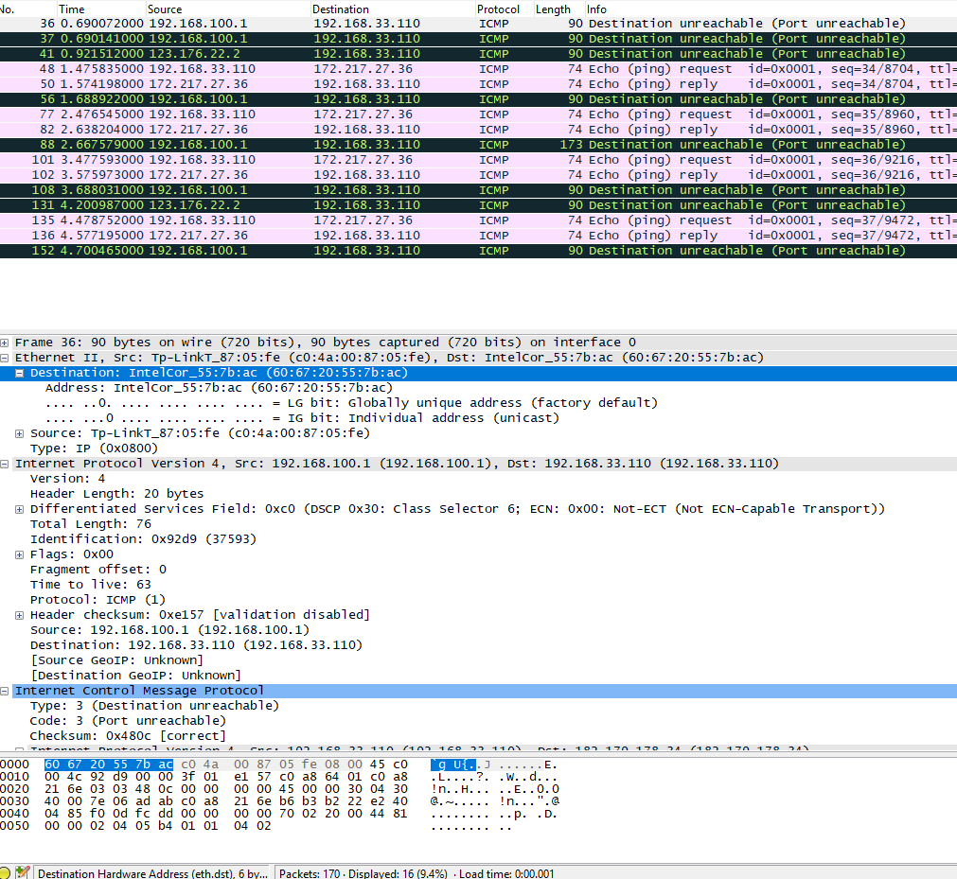

1. 2 requests are sent through host 1: TYPE 8: (echo (ping)request) 2:TYPE 0: (echo (ping)reply)
2. There are 4 accepted requests that are sent through the host.
3. Source IP: 192.168.33.110

Destination IP: 172.217.27.36

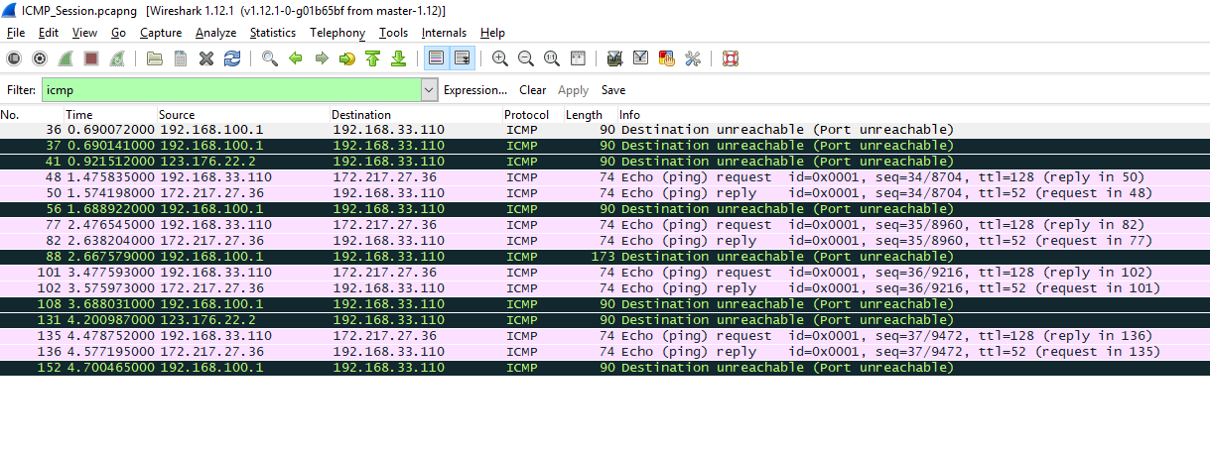

1. ICMP can only communicate between network layers hence, it has no source and destination port numbers.
2. Their type numbers differentiates request message from reply message. Request message has TYPE: 8 and reply messages has TYPE: 0
3. ICMP type is 8 and code number is 0

Checksum bytes are 0x4de39, sequence number bytes are 8995 (8960+35), identifier field has bytes 257(256+1)

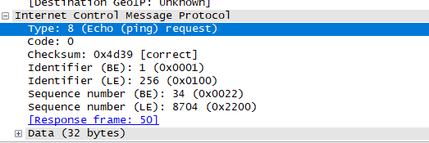

1. ICMP type is 0 and code number is 0

Checksum bytes are 0x4de39, sequence number bytes are 8738 (8704+34), identifier field has bytes 257(256+1)

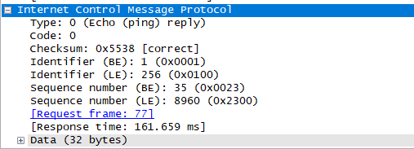

1. TYPE: 3

Code: 3

IP and TCP Header included in the ICMP Header for error handling and to help understand the error.